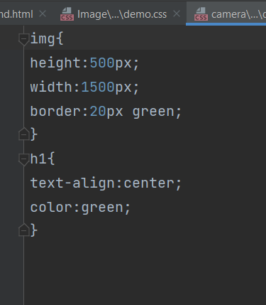

img{

height:500px;

width:1500px;

border:20px green;

}

h1{

text-align:center;

color:green;

}

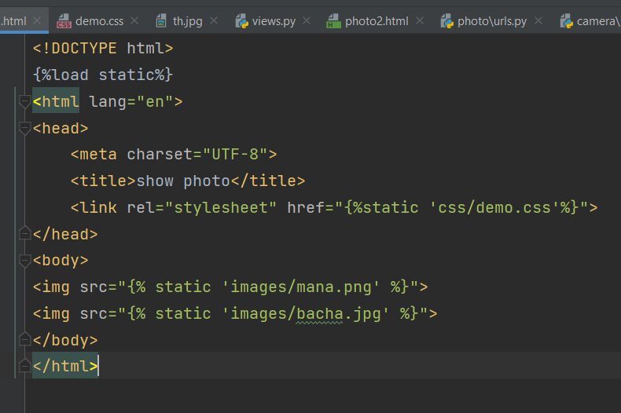

<!DOCTYPE html>

{%load static%}

<html lang="en">

<head>

<meta charset="UTF-8">

<title>show photo</title>

<link rel="stylesheet" href="{%static 'css/demo.css'%}">

</head>

<body>

<img src="{% static 'images/mana.png' %}">

<img src="{% static 'images/bacha.jpg' %}">

</body>

</html>

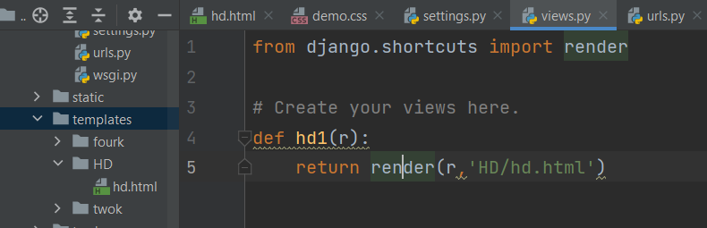

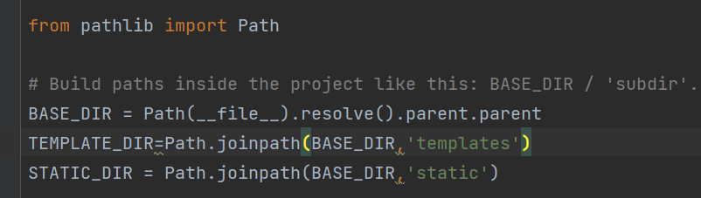

STATIC_DIR = Path.joinpath(BASE_DIR,'static')

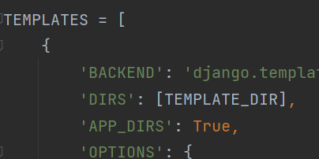

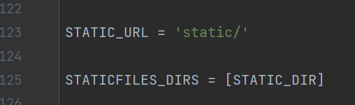

STATICFILES_DIRS = [STATIC_DIR]

